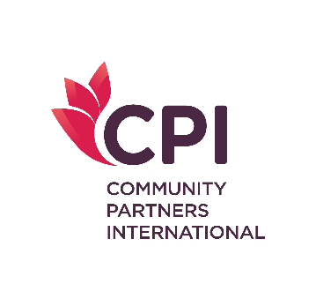

Scholarship Application for

Master of Public Health (MPH)

International Program

at Khon Kaen University, Thailand

REFERENCE STATEMENT
(To be completed by referee)

Name of Applicant (in block letters):

The person named above is applying to Community Partners International (CPI) for an academic scholarship to study on the Master of Public Health (MPH) program at Khon Kaen University. Please answer the questions below to the best of your knowledge to guide us in our consideration of this applicant. If you wish to make additional comments, please use an additional sheet. Thank you for your assistance.

- How long have you known the applicant and in what capacity?

- How do applicant’s achievements compare to those of her/his peers?

- For the applicant who holds professional qualifications or has professional experiences, how would the qualifications and/ or experiences contribute to the applicant’s suitability?

- Please comment on the applicant’s character and personality strengths.

- For an applicant whose first language is not English, please comment on her/his standard of proficiency in English.

- Statement of the applicant’s ability and potential to undertake the proposed program of study. (Please continue on an additional sheet if necessary)

- On the basis of character and personal promise, how would you recommend this applicant?

□ Highly recommend □ Recommend
□ Recommend with reservations □ Do not recommend

Title and name of referee:

Address:
E-mail:
Tel:
Signature:
Date:

